**1.Introduction**

#### **1.1 Objective of the Project:**

**The various Modules of the Restaurant Management System**

* Admin Module
* Employee Module
* Customer Module

**1.1.1 The Admin Module:**

* The administration module includes one major feature, adding to the database and modifying it also, such as adding items and deleting stock items to provide more choice of stocks for the User and visitor also.
* This page requires Login with password provided by developer as this software allows user to edit the database and add to it, a trusted person such as admin will get the password from developer.

**1.1.2 The User module:**

* Although so much of the functionalities offered by this software have being offered in the visitor module without requiring any registration or provision of identity. This module offers some more features which only users can access such as Storing scores and getting opportunity to appear the high scores table if high enough.
* The user module provides the user with corrections for the stock items kept and detailed overview of the billing system, where they failed and where the passed and also correct answers to the failed questions.
* The user module doesn’t require any password, just a username to and access is provided.
* A developer feedback section where the user can submit feedback to developer to help modify the software for better user satisfaction.
* The about section where the user can get to know the developer of the Software application and their full details.

**1.1.3 The Visitors module:**

* This module provides an unregistered user with enough functionality such as getting taking the details, submitting and getting their billings.
* In the visitor module the visitor can also seek online help during the ordering of food and get the resources they need to help them get familiar with the concepts found in the stock item pages.
* The visitor module has access to the database for only accessing the stock items which are displayed on the screen for user to billing. The visitor cannot make any change to the database or store anything. They can only view the employee login page and provide the remaining stock items.
* The visitor section is also user interactive and has the timer feature for taking the delivering of items specifically.

#### **2.System Analysis**

#### **2.1 System Analysis:**

System analysis is process of gathering and interpreting facts. Diagnosing problems and the information to recommend improvement on the system, it is problem solving activity that requires intensive communication between the system users and system developer, system analysis or study is an important phase of any system development process. The system is studied to the minuets detail and analysed. The system analyst plays the role of the interrogator and dwells deep into the working of the present system. The system is viewed as whole and the input to the system are identified. The output from the organization at traced to the various processes. System analysis is concerned with becoming aware of the problem identifying the relevant and decisional variables, analysing and synthesizing the various factors and determining and optimal or at least satisfactory solutions or program of action.

A detailed study of the process must be various techniques like interviews questionnaires etc. The data collected by these sources must be scrutinized to arrive to a conclusion. The conclusion is an understanding of how the system functions, this system is called the existing system. Now the existing system is subjected to close study and problem areas are identified. The designer now functions as a problem solver and tries to sort out the difficulties that the enterprise faces .The solutions are given as proposals The proposal is then weighed with the existing system analytically and the best one is selected .The proposal is presented to the user for an endorsement by the user The proposal is reviewed on user request and suitable changes are made This is loop that ends as soon as the user is satisfied with proposal.

Preliminary study is the process of gathering and interpreting facts, using the information for further studies on the system, preliminary study is problem solving activity that requires intensive communication between the system users and system developers, it dose various feasibility studies, in these studies in a rough figure of the system activities can be obtained, from which the decision about the strategies to be followed for effective system study and analysis can be taken. Here in the Email to fax server project, a detailed study of existing system is carried and the steps were followed.

**2.2 Existing System:**

The existing system is manual in nature, where they do all calculation manually large volumes of paper work is done and stored in files. Maintaining data is a tedious one and updating the records is not an easy job in existing system. If any information required then the user should refer the files ledgers where the details are stored. Daily updating is too difficult. So, the existing system is to be changed and put for computerization.

**2.2.1 Disadvantages of Existing System:**

* The study of existing system has thrown a light on various activities involved in the organization.
* Existing system is maintained manually.
* The work done by the existing system is separate and tedious to maintain.
* The registers are maintained separately for all the functions of the concern.
* Reports are not easily generated whenever it is needed.
* Security is less, lack of accuracy.

**2.3 Proposed System:**

It has been proposed to computerize the above mentioned existing manual system. The computerized system gives good solution for the above-mentioned problems. This proposed system has been computerized with Microsoft Visual Studio 8.0 as the front-end tool and Ms access 2010 as backend tool. This new software package has been developed completely on menu driven basis. The various inputs given to the proposed system are customer details, purchase details, employee details and sales details.

The above information is maintained and can be retrieved from the proposed system. This system has been developed to generate daily and periodical reports

**2.3.1 Advantages of Proposed System:**

* Provides Data security
* High processing speed
* Excellent data linkage
* Use of more constrains
* Duplication work is avoided
* Generations of reports are very quick
* Unlimited data size
* Less Time consuming

**2.4 Feasibility Study:**

Feasibility study is made to see if the project on completion will serve the purpose of the organization for the amount of work, effort and the time that spend on it. Feasibility study lets developer foresee the future of the project and the usefulness. a feasibility study of a system proposal is according to it is workability , which is impact on the organization ability to meet their user needs and effective use of resources .Thus when a new application is proposed it normally goes through feasibility study before it is approved for development .The document provide the feasibility of the project that is being designed and lists various areas that were considered very carefully during the feasibility study of this project such as technical ,economic operational feasibilities. The following are its features:

**2.4.1 Technical Feasibility:**

The system must be evaluated from the technical point of view first. The assessment of this feasibility must be based on an outline design of the system requirement in the terms of input, output, programs and producers. having identified an outline system, the investigation must go on to suggest the type of equipment, required method developing the system, of running the system once it has been designed technical issues raised during the investigation are

* Is the existing technology sufficient for the suggested one?
* Can the system expand if developed?

The project should be developed such that the necessary functions and performance archived within the constraint. The project is developed within latest technology. Though the technology may come obsolete after some period of time, due to the fact that newer version of same software support older versions, the system may still be used.so there are minimal constraint involved with this project. The software was developed using C# programming Language in Visual studio and Ms-Access for the backend Database, the project is technically feasible for development.

**2.4.2 Economic Feasibility**:

The developing system must be justified by cost and benefit criteria to ensure that effort is concentrated on project, which will give best, return at the earliest. One of the factors, which affect the development of a new system, is the cost it would require.

The following are the important financial questions asked during preliminary investigation:

* The cost through conducting a full system investigation.
* The cost of hardware and software.
* The benefits in the form of reduced or fewer costly errors.

Also, the resources are already available, it gives indication of the system is economically possible for development. And that’s why we succeeded in developing it.

**2.4.3 Behavioural Feasibility:**

This includes the following questions.

* Is there sufficient support for the user?
* Will the proposed system cause harm?

The project would be beneficial because it satisfies the objectives when developed and installed. All the behavioural aspects are considered carefully and concluded that the project is behaviourally feasible.

**2.5 Functional Requirements:**

The Functional requirements of the system are to implement the solution to store the inventory and the database which are done in Restaurant for a better management.

1. **Input/Output:**

The employee had to login and enter the details for the better analysis of retrieving the data for the inventory and to get the full information.

1. **Processing:**

The information regarding the stock and the order are retrieved from the inventory database.

1. **Storage Requirements:**

The information will be retrieved from the database.

1. **Operational Requirements:**

* User should be register to Login to the system.
* User should enter Item name, Id, Sales No, Stocks in order to store the data.
* Based on the data given the employee must choose what he has to retrieve from the database.
* Select the data and fill the required details.
* The database storing process should be done based on your filled details.

**2.6 Non-Functional Requirements:**

The Non-Functional requirements are the Characteristics of the Attributes which are the Functional requirements.

It’s the Properties of the Functionality offered by the Project. As compared to Functional Requirements, Functional requirements are what the Software should do and Non-Functional Requirements is the way it does it.

This Project has the Non-Functional requirements such as:

* + - **Usability**: Usability defines how difficult it will be for a user to learn and operate the system.
    - **Security:** Security requirements ensure that the software is protected from un authorised access to the system and its stored data
    - **Performance:** Performance is a quality attribute that describes the responsiveness of the system to the various users’ interactions.
    - **Availability:** Availability is measured by the period of that time that the system’s functionality and services are available for use with all system.
    - **Scalability**: Scalability requirements describes how the system must grow without negative influence on its performance.

**2.7 Requirements Specifications:**

**2.7.1 Software Requirement:**

**Operating System :**  Windows 10

**Front-End Technology :** C# in Visual Studio

**Back-End Technology :** Ms-Access

**2.7.2 Minimum Hardware Requirement:**

**Processor** : i3(2.0GHz) or higher

**RAM** : 2GB

**Hard Disk :** 20GB

**3.System Design**

**3.1 Introduction**

System design is a process through which requirements are translated into a representation of software. Initially the representation depicts a holistic view of software. Subsequent refinement leads to a design representation that is very close to source code. Design is a place where quality fostered in software development. Design provides us with representation of software that can be assessed for quality; this is the only way that can accurately translate the customer requirements into finished software product or system. System design serves as the foundation for all software engineering and software maintenance steps that follow.

We look the design process from three distinct perspectives:

* Conceptual Design
* Logical Design
* Physical Design

             The higher view is the conceptual view, followed by the logical view and finally the physical view. In designing an application, we generally begin and end each phase in a sequentially order, although they may overlap one another along the way.

**a) Conceptual Design:**

 Conceptual Design is the process of acquiring and evaluating, documenting and then validating what the user envisions to be the business relation. It identifies the user and business requirements of the application and leads to a business solution as seen by the user.

               All applications are built to solve business problems, and it is important to pay close attention to principle that the business need drives application development. At any point in the design process, the current state of the design should be directly traceable to a business problem and requirements.

              To achieve this conceptual design is driven by developing usage scenarios. These scenarios are a direct representation of the user’s view of the solution to a specific business problem. A conceptual view places the emphasize on solving a business problem and deriving a solution that corresponds to the needs and requirements of the users. It is based on deriving the behaviour of the solution with a primary emphasizes on the user. Beginning with an emphasis on the activities of the business rather than aspects of software development, underscores the fact that systems exists to serve the business. A strong focus on the user in the beginning of the project will help in maintaining a proper perspective throughput the development lifecycle. The conceptual design results in the first description of what the system does to solve the business problem articulated in the vision/scope document.

**b) Logical Design**

Logical Design derives business objects and their related services directly from these usage scenarios. The logical view of the solution provides a basis for evaluating different physical options. It also formalizes the solution for the project team.

         The idea of the application is that the system first emerges in logical design. Its boundaries and business objects and it contain the system definition. Logical design specifies the interfaces between the system and external entities, such as users and other systems. Within a system there may be a number of sub-systems, and these boundaries are also specified.

Logical System Design consists of the following steps:

* Input/output Specifications
* File Specifications
* Processing Specifications

         Logical design should be technologically independent as possible, in order to separate system behaviour issues from system implementation issues. Implementation constraints should only be considered only after the project team verifies that the essential behaviour has been incorporated onto a logical design. This approach does not establish a technical direction until the system is well understood and documented.

**c) Physical Design**

The purpose of Physical Design is to translate the logical design into a solution that can be implemented effectively, according to performance, administration and development process requirements. This physical view should correctly implement the desired system behaviour while meeting the constraints imposed by the technology.

             In Physical Design, the perspective shifts from an abstraction of system behaviour to an implementation of the behaviour. Whereas the logical design is largely technology independent, physical design is necessarily tied to chosen set of technologies, these being the hardware and software on which the application will run.

            The aim of physical design is to specify how to build portioned applications from software components. The interaction of these components through defined interfaces results in the desired behaviour of the system as a whole. The rules for communicating between components are defined by interaction standards: what a component does and how it communicates are major considerations in physical design.

Physical design consists of the following steps:

 1. Design the physical media

* Specify input/output media.
* Design the database and specify backup procedures.
* Design physical information flow through the system.

2. Plan the system implementation

* Prepare a conversion schedule target date.
* Determine training procedure, courses and timetable.

3. Device a test and implementation plan.

4. Specify any new Hardware/Software usage.

5. Update benefits, costs, conversion date and system constraints.

**d) Database Design**

The general theme behind a database is to handle information as an integrated whole. A database is a collection of interrelated data stored with minimum redundancy to serve many users quickly and efficiently. The general objective is to make information access easy quick and flexible for user. In database design several objectives are considered.

**Control Redundancy:**

Redundant occupies space and therefore, is wasteful. If versions of the data are in different phases of updating the system often gives conflicting information. A unique aspect of database design is storing only once, which controls redundancy and improves system performance.

* 1. **UML Diagrams**

A diagram is the graphical representation of a set of elements, most often rendered as a connected graph of vertices and arcs. You draw diagram to visualize a system from different perspective, so a diagram is a projection into a system. For all but most trivial systems, a diagram represents an elided view of the elements that make up a system. The same element may appear in all diagrams, only a few diagrams, or in no diagrams at all. In theory, a diagram may contain any combination of things and relationships. In practice, however, a small number of common combinations arise, which are consistent with the five most useful views that comprise the architecture of a software-intensive system. For this reason, the UML includes nine such diagrams:

1. Class diagram

2. Object diagram

3. Use case diagram

4. Sequence diagram

5. Collaboration diagram

6. State chart diagram

7. Activity diagram

8. Component diagram

9.Deployment diagram

**Use Case:**

A use case is a list of action or event steps typically defining the interactions between a role (known in the unified Modelling language UML as an actor) and a system to achieve a goal. The actor can be a human or other External System.

Use case analysis is an important and valuable requirement analysis technique that has been widely used in modern software engineering.

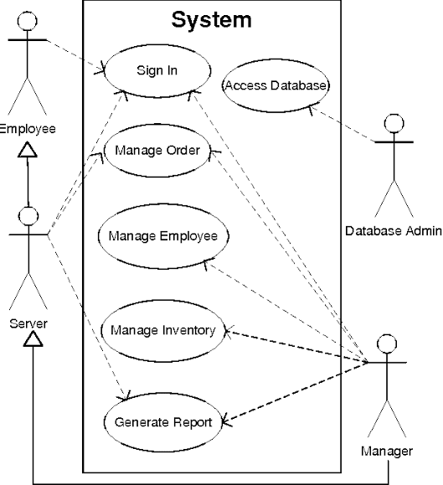

**Fig 3.3.1 Use Case diagram for Restaurant database management system**

**Class Diagram:**

A cla**ss** is a category or group of things that has similar attributes and common behaviour. A Rectangle is the icon that represents the class it is divided into three areas. The upper most area contains the name, the middle, area contains the attributes and the lowest areas show the operations. Class diagrams provides the representation that developers work from and also helps on the analysis side.

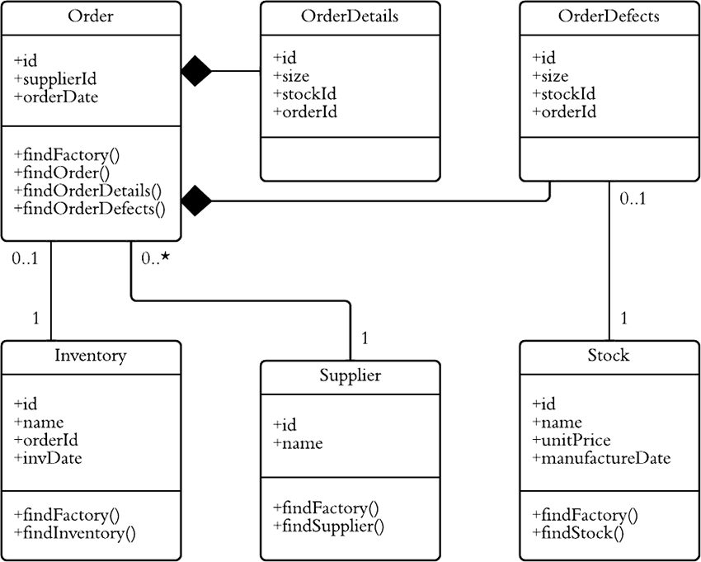

**Fig 3.3.2 Class Diagram for Restaurant database management system**

**Sequence Diagram:**

A **Sequence Diagram** is an interaction diagram that emphasis the time ordering of messages; a collaboration diagram is an interaction diagram that emphasizes the structural organization of the objects that send and receive messages. Sequence diagrams and collaboration diagrams are isomorphic, meaning that you can take one and transform it into the other.

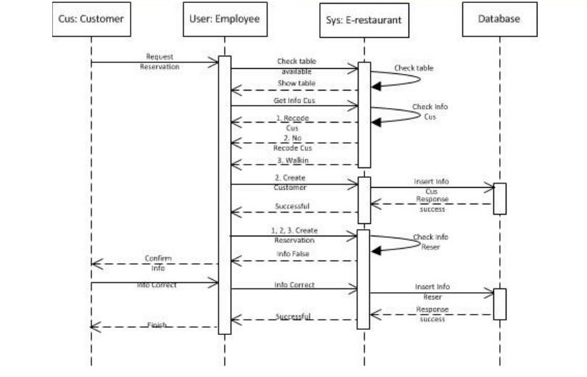

**Fig 3.3.3 Sequence Diagram for Restaurant database management system**

**Entity Relation Diagram:**

An ER diagram shows the relationship among entity sets. An entity set is a group of similar entities and these entities can have attributes. In terms of DBMS, an entity is a table or attribute of a table in database, so by showing relationship among tables and their attributes, ER diagram shows the complete logical structure of a database.

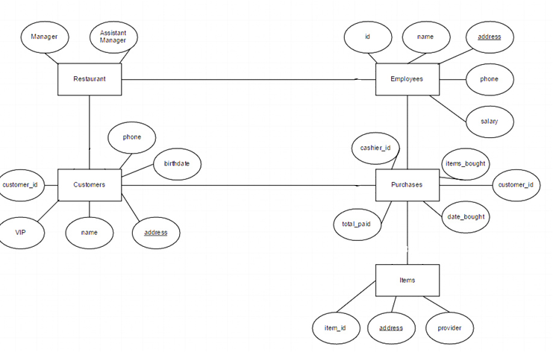

**Fig 3.3.4 E R Diagram** **for Restaurant database management system**

## **3.4 Data Dictionary:**

**3.4.1 Employee Table**

|  |  |  |  |  |
| --- | --- | --- | --- | --- |
| **Field Name** | **Data Type** | **Size** | **Key** | **Description** |
| emp_id | Number | Long Integer | Primary key | Employee id |
| Name | Text | 255 |  | Employee name |
| Designation | Text | 255 |  | Employee designation |
| Gender | Text | 255 |  | Employee gender |
| Address | Text | 255 |  | Employee address |
| Salary | Number | Long Integer |  | Employee salary |
| Phone no | Number | Long Integer |  | Employee phone no |
| Date | Date/Time | Short Date |  | Employee joining date |

**3.4.2 Login Table:**

|  |  |  |  |  |
| --- | --- | --- | --- | --- |
| Field Name | Data Type | Size | Key | **Description** |
| Emp-id | Number | Long Integer | Primary Key | Employee Id |
| User Name | Text | 255 |  | User Name |
| Password | Text | 255 |  | Password |

**3.4.3 Storage Table:**

|  |  |  |  |  |
| --- | --- | --- | --- | --- |
| Field Name | Data Type | Size | Key | **Description** |
| Item-Id | Number | Long Integer | Primary Key | Item id |
| Item-Name | Text | 255 |  | Item name |
| Company | Text | 255 | Foreign key | Company name |
| Quantity | Number | Long integer |  | Item quantity |

**3.4.4 Items Table:**

|  |  |  |  |  |
| --- | --- | --- | --- | --- |
| Field Name | Data Type | Size | Key | **Description** |
| Item-id | Number | Long integer | Primary Key | Item id |
| Item-name | Text | 255 |  | Item name |
| Company | Text | 255 | Foreign key | Item company |
| MFQ | Date/Time | Short date |  | Manufacture date |
| Exp Date | Date/Time | Short date |  | Expiry date |
| Price In | Number | Long Integer |  | Item price |
| Price-Out | Number | Long Integer |  | Selling price |

**3.4.5 Company Table**

|  |  |  |  |  |
| --- | --- | --- | --- | --- |
| Field Name | Data Type | Size | Key | **Description** |
| Comp-Id | Number | Long Integer | Primary Key | Company id |
| CompanyName | Text | 255 |  | Company name |
| Add | Text | 255 |  | Company address  A |
| Ph no | Number | Long Integer |  | Company phone no |
| E-Mail | Text | 255 |  | Company E-mail |

**3.4.6 Spends Table:**

|  |  |  |  |  |
| --- | --- | --- | --- | --- |
| Field Name | Data Type | Size | Key | **Description** |
| S-Id | Number | Long Integer | Primary Key | Spends id |
| Emp-Id | Number | Long Integer | Foreign key | Employee id |
| Reason | Text | 255 |  | Reason |
| Amount | Number | Long Integer |  | Amount |
| Date | Date/Time | Short Date |  | Date |

**3.4.7 Sales Table:**

|  |  |  |  |  |
| --- | --- | --- | --- | --- |
| Field Name | Data Type | Size | Key | **Description** |
| Bill No | Number | Long Integer | Auto No | Billing No |
| Item-Id | Number | Long Integer | Foreign key | Item Id |
| Item-Name | Text | 255 |  | Item Name |
| Price | Number | Long Integer |  | Item price |
| Quantity | Number | Long Integer |  | Item quantity |
| Total | Number | Long Integer |  | Total price |
| Date | Date/Time | Short Date |  | Date of purchase |
| Cust Ph No | Number | Long Integer |  | Customer phone no |

**4. Technology Description**

##### **4.1. Introduction to C#:**

C# is a simple, modern, general-purpose, object-oriented programming language developed by Microsoft within its .NET initiative led by Anders Hejlsberg. This tutorial will teach you basic C# programming and will also take you through various advanced concepts related to C# programming language.

C# is a modern, general-purpose, object-oriented programming language developed by

Microsoft and approved by European Computer Manufacturers Association (ECMA) and International Standards Organization (ISO).

C# was developed by Anders Hejlsberg and his team during the development of .Net Framework. C# is designed for Common Language Infrastructure (CLI), which consists of the executable code and runtime environment that allows use of various high-level languages on different computer platforms and architectures.

The following reasons make C# a widely used professional language −

* It is a modern, general-purpose programming language It is object oriented.
* It is component oriented.
* It is easy to learn.
* It is a structured language.
* It produces efficient programs.
* It can be compiled on a variety of computer platforms.
* It is a part of .Net Framework.

**Strong Programming Features of C#:**

Although C# constructs closely follow traditional high-level languages, C and C++ and being an object-oriented programming language. It has strong resemblance with Java, it has numerous strong programming features that make it endearing to a number of programmers worldwide.

**Following is the list of few important features of C# −**

* Boolean Conditions
* Automatic Garbage Collection
* Standard Library
* Assembly Versioning
* Properties and Events
* Delegates and Events Management
* Easy-to-use Generics
* Indexers
* Conditional Compilation
* Simple Multithreading
* LINQ and Lambda Expressions
* Integration with Windows

### **4.2 The .Net Framework:**

The .Net framework is a revolutionary platform that helps you to write the following types of applications −

Windows applications

Web applications

Web services

The .Net framework applications are multi-platform applications. The framework has been designed in such a way that it can be used from any of the following languages: C#, C++, Visual Basic, Jscript, COBOL, etc. All these languages can access the framework as well as communicate with each other.

The .Net framework consists of an enormous library of codes used by the client languages such as C#. Following are some of the components of the .Net framework −

Common Language Runtime (CLR)

The .Net Framework Class Library

Common Language Specification

Common Type System

Metadata and Assemblies

Windows Forms

ASP.Net and ASP.Net AJAX

ADO.Net

Windows Workflow Foundation (WF)

Windows Presentation Foundation

Windows Communication Foundation (WCF)

LINQ

For the jobs each of these components perform, please see ASP.Net - Introduction, and for details of each component, please consult Microsoft's documentation. Integrated Development Environment (IDE) for C#

**Microsoft provides the following development tools for C# programming −**

Visual Studio 2010 (VS)

Visual C# 2010 Express (VCE)

Visual Web Developer

The last two are freely available from Microsoft official website. Using these tools, you can write all kinds of C# programs from simple command-line applications to more complex applications. You can also write C# source code files using a basic text editor, like Notepad, and compile the code into assemblies using the command-line compiler, which is again a part of the .NET Framework.

Visual C# Express and Visual Web Developer Express edition are trimmed down versions of Visual Studio and has the same appearance. They retain most features of Visual Studio. In this tutorial, we have used Visual C# 2010 Express.

You can download it from Microsoft Visual Studio. It gets installed automatically on your machine.

**Note**: You need an active internet connection for installing the express edition.

**Writing C# Programs on Linux or Mac OS**

Although the.NET Framework runs on the Windows operating system, there are some alternative versions that work on other operating systems. Mono is an open-source version of the .NET Framework which includes a C# compiler and runs on several operating systems, including various flavours of Linux and Mac OS. Kindly check Go Mono.

The stated purpose of Mono is not only to be able to run Microsoft .NET applications cross-platform, but also to bring better development tools for Linux developers. Mono can be run on many operating systems including Android, BSD, iOS, Linux, OS X, Windows, Solaris, and UNIX.

##### **4.3 Database:**

Database is a systematic collection of data. Databases support storage and manipulation of data. Databases make data management easy. Let's discuss few examples.

An online telephone directory would definitely use database to store data pertaining to people, phone numbers, other contact details, etc.

Your electricity service provider is obviously using a database to manage billing, client related issues, to handle fault data, etc.

Let's also consider the Facebook. It needs to store, manipulate and present data related to members, their friends, member activities, messages, advertisements and lot more.

##### We can provide countless number of examples for usage of databases.

##### **4.4 My Access:**

Microsoft Access is a Database Management System offered by Microsoft. It uses the Microsoft Jet Database Engine and comes as a part of the Microsoft Office suite of application.

Microsoft Access offers the functionality of a database and the programming capabilities to create easy to navigate screens (forms).

### **Database File:**

It is a file which stores the entire database. The database file is saved to your hard drive or other storage devices.

### **Datatypes:**

Datatypes are the properties of each field. Every field has one datatype like text, number, date, etc.

### **Table:**

* A Table is an object which stores data in Row & Column format to store data.
* A Table is usually related to other tables in the database file.
* Each column must have Unique name
* We can also define Primary Key in a table.

### **Query:**

* Queries answer a question by selecting and sorting and filtering data based on search criteria.
* Queries show a selection of data based on criteria (limitations) you provide.
* Queries can pull from one or more related Tables and other Queries.
* Types of Query can be SELECT, INSERT, UPDATE, DELETE.

### **Form:**

* A form is a database object that you can use to create a user interface for a database application.
* Forms help you to display live data from the table. It mainly used to ease the process of data entry or editing.

### **Report:**

* A report is an object in desktop databases primarily used for formatting, calculating, printing, and summarizing selected data.
* You can even customize the report's look and feel.

### **Macros:**

Macros are mini computer programming constructs. They allow you to set up commands and processes in your forms, like, searching, moving to another record, or running a formula.

### **Modules:**

Modules are procedures(functions) which you can write using Visual Basic for Applications (VBA).

A **Relational Database Management System (RDBMS)** is a software that −

* Enables you to implement a database with tables, columns and indexes.
* Guarantees the Referential Integrity between rows of various tables.
* Updates the indexes automatically.
* Interprets an SQL query and combines information from various tables.

**4.5 RDBMS Terminology:**

Before we proceed to explain the MyAccess database system, let us revise a few definitions related to the database.

* **Database** − A database is a collection of tables, with related data.
* **Table** − A table is a matrix with data. A table in a database looks like a simple spreadsheet.
* **Column** − One column (data element) contains data of one and the same kind, for example the column postcode.
* **Row** − A row (= tuple, entry or record) is a group of related data, for example the data of one subscription.
* **Redundancy** − Storing data twice, redundantly to make the system faster.
* **Primary Key** − A primary key is unique. A key value cannot occur twice in one table.

With a key, you can only find one row.

* **Foreign Key** − A foreign key is the linking pin between two tables.
* **Compound Key** − A compound key (composite key) is a key that consists of multiple columns, because one column is not sufficiently unique.
* **Index**: an index in a database resembles an index at the back of a book.
* **Referential Integrity**: Referential Integrity makes sure that a foreign key value always points to an existing row.

**4.6 Advantages of Ms Access:**

* Access offers a fully functional, relational database management system in minutes.
* Easy to import data from multiple sources into Access
* You can easily customize Access according to personal and company needs
* Access works well with many of the development languages that work on Windows OS
* It is robust and flexible, and it can perform any challenging office or industrial database tasks.
* MS-Access allows you to link to data in its existing location and use it for viewing, updating, querying, and reporting.
* Allows you to create tables, queries, forms, and reports, and connect with the help of Macros
* Macros in Access is a simple programming construct with which you can use to add functionality to your database.
* It can perform heterogeneous joins between various data sets stored across different platforms

**5.Sample Code**

**5.1 Login Form:**

using System;

using System.Collections.Generic;

using System.ComponentModel;

using System.Data;

using System.Drawing;

using System.Linq;

using System.Text;

using System.Windows.Forms;

using System.Data.OleDb;

namespace WindowsFormssApplication2

{

public partial class Form1 : Form

{

public Form1()

{

InitializeComponent();

}

private void button1_Click(object sender, EventArgs e)

{

try

{

OleDbConnection con = new OleDbConnection();

con.ConnectionString = "Provider=Microsoft.ACE.OLEDB.12.0;Data Source=|DataDirectory|res.accdb";

con.Open();

string sql = "select * from accs where usernamee='" + textBox1.Text + "'AND passwordd='" + textBox2.Text + "'";

OleDbCommand cmd = new OleDbCommand(sql, con);

OleDbDataReader myread;

myread = cmd.ExecuteReader();

if (myread.Read())

{

con.Close();

HOME hh = new HOME();

hh.Show();

this.Hide();

}

else

{

MessageBox.Show("WRONG DATA");

}

}

catch

{

MessageBox.Show("WRONG DATA");

}

}

private void button2_Click(object sender, EventArgs e)

{

Application.Exit();

}

}

}

**5.2 Main Page Form:**

using System;

using System.Collections.Generic;

using System.ComponentModel;

using System.Data;

using System.Drawing;

using System.Linq;

using System.Text;

using System.Windows.Forms;

namespace WindowsFormsApplication2

{

public partial class HOME : Form

{

public HOME()

{

InitializeComponent();

}

private void button1_Click(object sender, EventArgs e)

{

Application.Exit();

}

private void spendsToolStripMenuItem_Click(object sender, EventArgs e)

{

spendds S = new spendds();

S.Show();

this.Close();

}

private void accountToolStripMenuItem_Click(object sender, EventArgs e)

{

accounts S = new accounts();

S.Show();

this.Close();

}

private void employeeToolStripMenuItem1_Click(object sender, EventArgs e)

{

employee S = new employee();

S.Show();

this.Close();

}

private void itemToolStripMenuItem_Click(object sender, EventArgs e)

{

items S = new items();

S.Show();

this.Close();

}

private void companyToolStripMenuItem_Click(object sender, EventArgs e)

{

Company S = new Company();

S.Show();

this.Close();

}

private void storageToolStripMenuItem_Click(object sender, EventArgs e)

{

Storage hh = new Storage();

hh.Show();

this.Close();

}

private void saleToolStripMenuItem_Click(object sender, EventArgs e)

{

Sales_Point hh = new Sales_Point();

hh.Show();

this.Close();

}

private void aboutUsToolStripMenuItem1_Click(object sender, EventArgs e)

{

Aboutus hh = new Aboutus();

hh.Show();

this.Close();

}

}

}

**5.3 Employee Form:**

using System;

using System.Collections.Generic;

using System.ComponentModel;

using System.Data;

using System.Drawing;

using System.Linq;

using System.Text;

using System.Windows.Forms;

using System.Data.OleDb;

namespace WindowsFormsApplication2

{

public partial class employee : Form

{

public employee()

{

InitializeComponent();

}

private void button5_Click(object sender, EventArgs e)

{

try

{

OleDbConnection con = new OleDbConnection();

con.ConnectionString = "Provider=Microsoft.ACE.OLEDB.12.0;Data Source=|DataDirectory|res.accdb";

con.Open();

string sql = "select * from employee where emp_id=" + textBox1.Text;

OleDbCommand cmd = new OleDbCommand(sql, con);

OleDbDataReader myread;

myread = cmd.ExecuteReader();

myread.Read();

textBox1.Text = myread.GetValue(0).ToString();

textBox2.Text = myread.GetString(1);

comboBox2.Text = myread.GetValue(2).ToString();

comboBox1.Text = myread.GetString(3);

textBox3.Text = myread.GetString(4);

textBox4.Text = myread.GetValue(5).ToString();

textBox5.Text = myread.GetValue(6).ToString();

dateTimePicker1.Text = myread.GetDateTime(7).ToShortDateString();

con.Close();

}

catch

{

MessageBox.Show("WRONG DATA");

}

}

private void button1_Click(object sender, EventArgs e)

{

textBox1.Clear();

textBox2.Clear();

textBox3.Clear();

textBox4.Clear();

textBox5.Clear();

dateTimePicker1.Text = "";

comboBox1.Text = "";

comboBox2.Text = "";

}

private void button2_Click(object sender, EventArgs e)

{

try

{

OleDbConnection con = new OleDbConnection();

con.ConnectionString = "Provider=Microsoft.ACE.OLEDB.12.0;Data Source=|DataDirectory|res.accdb";

con.Open();

string sql = "insert into employee values(" + textBox1.Text + ",'" + textBox2.Text + "','" + comboBox2.Text + "','" + comboBox1.Text + "','" + textBox3.Text + "'," + textBox4.Text + "," + textBox5.Text + ",'" + dateTimePicker1.Value.ToShortDateString() + "')";

OleDbCommand cmd = new OleDbCommand(sql, con);

cmd.ExecuteNonQuery();

MessageBox.Show("DATA SAVED !");

textBox1.Clear();

textBox2.Clear();

textBox3.Clear();

textBox4.Clear();

textBox5.Clear();

dateTimePicker1.Text = "";

comboBox1.Text = "";

comboBox2.Text = "";

con.Close();

}

catch

{

MessageBox.Show("WRONG DATA check once again");

}

}

private void button3_Click(object sender, EventArgs e)

{

try

{

OleDbConnection con = new OleDbConnection();

con.ConnectionString = "Provider=Microsoft.ACE.OLEDB.12.0;Data Source=|DataDirectory|res.accdb";

con.Open();

string sql = "delete from employee where emp_id=" + textBox1.Text;

OleDbCommand cmd = new OleDbCommand(sql, con);

cmd.ExecuteNonQuery();

MessageBox.Show("DATA deleted !");

textBox1.Clear();

textBox2.Clear();

textBox3.Clear();

textBox4.Clear();

textBox5.Clear();

dateTimePicker1.Text = "";

comboBox1.Text = "";

comboBox2.Text = "";

con.Close();

}

catch

{

MessageBox.Show("not deleted!");

}

}

private void button4_Click(object sender, EventArgs e)

{

try

{

OleDbConnection con = new OleDbConnection();

con.ConnectionString = "Provider=Microsoft.ACE.OLEDB.12.0;Data Source=|DataDirectory|res.accdb";

con.Open();

string sql = "update employee set Name ='" + textBox2.Text + "',DESIGNATION='" + comboBox2.Text + "',Gender='" + comboBox1.Text + "',address='" + textBox3.Text + "',Salary=" + textBox4.Text + ",Phone_no=" + textBox5.Text + ",date='" + dateTimePicker1.Value.ToShortDateString() + "' where emp_id=" + textBox1.Text;

OleDbCommand cmd = new OleDbCommand(sql, con);

cmd.ExecuteNonQuery();

MessageBox.Show("DATA updated !");

textBox1.Clear();

textBox2.Clear();

textBox3.Clear();

textBox4.Clear();

dateTimePicker1.Text = "";

comboBox2.Text = "";

comboBox1.Text = "";

con.Close();

}

catch

{

MessageBox.Show("not updated!");

}

}

private void button8_Click(object sender, EventArgs e)

{

HOME hh = new HOME();

hh.Show();

this.Close();

}

private void button6_Click(object sender, EventArgs e)

{

Application.Exit();

}

private void button7_Click_1(object sender, EventArgs e)

{

try

{

OleDbConnection con = new OleDbConnection();

con.ConnectionString = "Provider=Microsoft.ACE.OLEDB.12.0;Data Source=|DataDirectory|res.accdb";

con.Open();

string sql = "update employee set Name ='" + textBox2.Text + "',DESIGNATION='" + comboBox2.Text + "',Gender='" + comboBox1.Text + "',address='" + textBox3.Text + "',Salary=" + textBox4.Text + ",Phone_no=" + textBox5.Text + ",date='" + dateTimePicker1.Value.ToShortDateString() + "' where emp_id=" + textBox1.Text;

OleDbCommand cmd = new OleDbCommand(sql, con);

cmd.ExecuteNonQuery();

MessageBox.Show("DATA updated !");

textBox1.Clear();

textBox2.Clear();

textBox3.Clear();

textBox4.Clear();

dateTimePicker1.Text = "";

comboBox2.Text = "";

comboBox1.Text = "";

con.Close();

}

catch

{

MessageBox.Show("not updated!");

}

}

}

}

**5.4 Sales Form:**

using System;

using System.Collections.Generic;

using System.ComponentModel;

using System.Data;

using System.Drawing;

using System.Linq;

using System.Text;

using System.Windows.Forms;

using System.Data.OleDb;

namespace WindowsFormsApplication2

{

public partial class Sales_Point : Form

{

public Sales_Point()

{

InitializeComponent();

}

private void button6_Click(object sender, EventArgs e)

{

Application.Exit();

}

private void textBox8_TextChanged(object sender, EventArgs e)

{

OleDbConnection con = new OleDbConnection();

con.ConnectionString = "Provider=Microsoft.ACE.OLEDB.12.0;Data Source=|DataDirectory|res.accdb";

con.Open();

string sql = "select item_name from items where Item_name like'" + textBox8.Text + "%'";

DataSet ds = new DataSet();

OleDbDataAdapter da = new OleDbDataAdapter(sql, con);

da.Fill(ds);

listBox1.DataSource = ds.Tables[0];

listBox1.DisplayMember = "Item_name";

con.Close();

}

private void button8_Click(object sender, EventArgs e)

{

HOME hh = new HOME();

hh.Show();

this.Close();

}

private void button1_Click(object sender, EventArgs e)

{

int sum = 0;

for (int i = 0; i < dataGridView1.Rows.Count; ++i)

{

sum += Convert.ToInt32(dataGridView1.Rows[i].Cells[4].Value);

}

try

{

OleDbConnection con = new OleDbConnection();

con.ConnectionString = "Provider=Microsoft.ACE.OLEDB.12.0;Data Source=|DataDirectory|res.accdb";

con.Open();

string sql = "insert into salespoint(Total,datee,Cust_Ph_no) values(" + sum + ",'" + DateTime.Today.ToShortDateString() + "'," + textBox1.Text + ")";

OleDbCommand cmd = new OleDbCommand(sql, con);

cmd.ExecuteNonQuery();

MessageBox.Show("PAYMENT DONE !");

con.Close();

}

catch

{

MessageBox.Show("WRONG DATA check once again");

}

}

private void button2_Click(object sender, EventArgs e)

{

}

private void listBox1_DoubleClick(object sender, EventArgs e)

{

OleDbConnection con = new OleDbConnection();

con.ConnectionString = "Provider=Microsoft.ACE.OLEDB.12.0;Data Source=|DataDirectory|res.accdb";

con.Open();

string sql = "select * from items where Item_name='" + listBox1.Text + "'";

OleDbDataReader muread;

OleDbCommand cmd = new OleDbCommand(sql, con);

muread = cmd.ExecuteReader();

muread.Read();

dataGridView1.Rows.Add(muread.GetValue(0).ToString(), muread.GetString(1), muread.GetValue(6).ToString());

}

private void dataGridView1_DoubleClick(object sender, EventArgs e)

{

try

{

int rowindex = dataGridView1.CurrentCell.RowIndex;

int colindex = dataGridView1.CurrentCell.ColumnIndex;

dataGridView1.Rows[rowindex].Cells[colindex].Value = int.Parse(dataGridView1.Rows[rowindex].Cells[2].Value.ToString()) * int.Parse(dataGridView1.Rows[rowindex].Cells[3].Value.ToString());

dataGridView1.Rows[rowindex].Cells[5].Value = DateTime.Today.ToShortDateString();

}

catch

{

}

}

private void button2_Click_1(object sender, EventArgs e)

{

}

}

}

# 6.Software Testing

**6.1 INTRODUCTION TO TESTING**

Testing is a process, which reveals errors in the program. It is the major quality measure employed during software development. During software development. During testing, the program is executed with a set of test cases and the output of the program for the test cases is evaluated to determine if the program is performing as it is expected to perform.

**6.2 TESTING STRATEGIES**

In order to make sure that the system does not have errors, the different levels of testing strategies that are applied at differing phases of software development are:

**6.2.1 Unit Testing:**

Unit Testing is done on individual modules as they are completed and become executable. It is confined only to the designer's requirements.

Each module can be tested using the following two Strategies:

**a) Black Box Testing:**

In this strategy some test cases are generated as input conditions that fully execute all functional requirements for the program. This testing has been uses to find errors in the following categories:

* Incorrect or missing functions
* Interface errors
* Errors in data structure or external database access
* Performance errors
* Initialization and termination errors.

In this testing only the output is checked for correctness.

The logical flow of the data is not checked.

**b) White Box Testing:**

In this the test cases are generated on the logic of each module by drawing flow graphs of that module and logical decisions are tested on all the cases. It has been used to generate the test cases in the following cases:

* Guarantee that all independent paths have been executed.
* Execute all logical decisions on their true and false Sides.
* Execute all loops at their boundaries and within their operational bounds
* Execute internal data structures to ensure their validity.

**6.2.2 Integration Testing:**

Integration testing ensures that software and subsystems work together a whole. It tests the interface of all the modules to make sure that the modules behave properly when integrated together.

[

**6.2.3 System Testing:**

Involves in-house testing of the entire system before delivery to the user. Its aim is to satisfy the user the system meets all requirements of the client's specifications.

**6.2.4 Acceptance Testing:**

It is a pre-delivery testing in which entire system is tested at client's site on real world data to find errors.

#### 

#### **6.3 Testing Approach:**

* Testing can be done in two ways:
* **[**
* Top down approach
* Bottom up approach

[[

**Top down approach:**

This type of testing starts from upper level modules. Since the detailed activities usually performed in the lower level routines are not provided stubs are written. A stub is a module shell called by upper level module and that when reached properly will return a message to the calling module indicating that proper interaction occurred. No attempt is made to verify the correctness of the lower level module.

**Bottom up Approach:**

Testing can be performed starting from smallest and lowest level modules and proceeding one at a time. For each module in bottom up testing a short program executes the module and provides the needed data so that the module is asked to perform the way it will when embedded within the larger system. When bottom level modules are tested attention turns to those on the next level that use the lower level ones they are tested individually and then linked with the previously examined lower level modules.

**Validation:**

The system has been tested and implemented successfully and thus ensured that all the requirements as listed in the software requirements specification are completely fulfilled. In case of erroneous input corresponding error messages are displayed

For example, you can write a JavaScript function to verify that users enter valid information into a form requesting a telephone number or zip code. Without any network transmission, an Html page with embedded Java Script can interpret the entered text and alert the user with a message dialog if the input is invalid or you can use JavaScript to perform an action (such as play an audio file, execute an applet, or communicate with a plug-in) in response to the user opening or exiting a page.

## **Test case:**

A test case is a document, which has a set of test data, preconditions, expected results and postconditions, developed for a particular test scenario in order to verify compliance against a specific requirement.

Test Case acts as the starting point for the test execution, and after applying a set of input values, the application has a definitive outcome and leaves the system at some end point or also known as execution postcondition.

**6.4 Sample Test case specifications:**

|  |  |  |  |  |  |  |  |
| --- | --- | --- | --- | --- | --- | --- | --- |
| Test case id | Test Case Name | | | Input | | Expected Output | Expected Result |
| T1 | User name | | | Enter valid user name | | Next page generated | Pass |
| T2 | User Name | | | Enter invalid username | | Invalid Username | Pass |
| T3 | Password | | | Password | | Successfully  login | Pass |
| T4 | Password | | | Invalid Password | | Error Message Shown | Pass |
| T5 | Username | | | Invalid username | | Next page Displayed | Fail |
| T6 | | Password | Invalid password | | Next page Displayed | | Fail |

**7.INPUT/OUTPUT SCREENSHOTS**

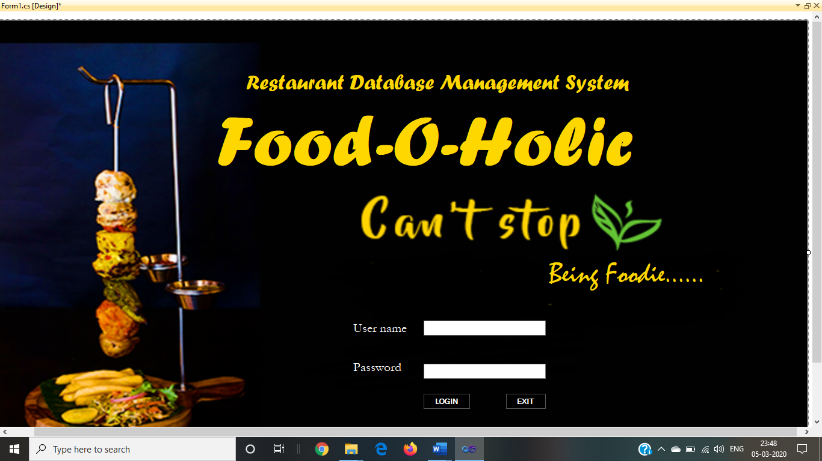

**FIG 7.1 Login page of restaurant management system**

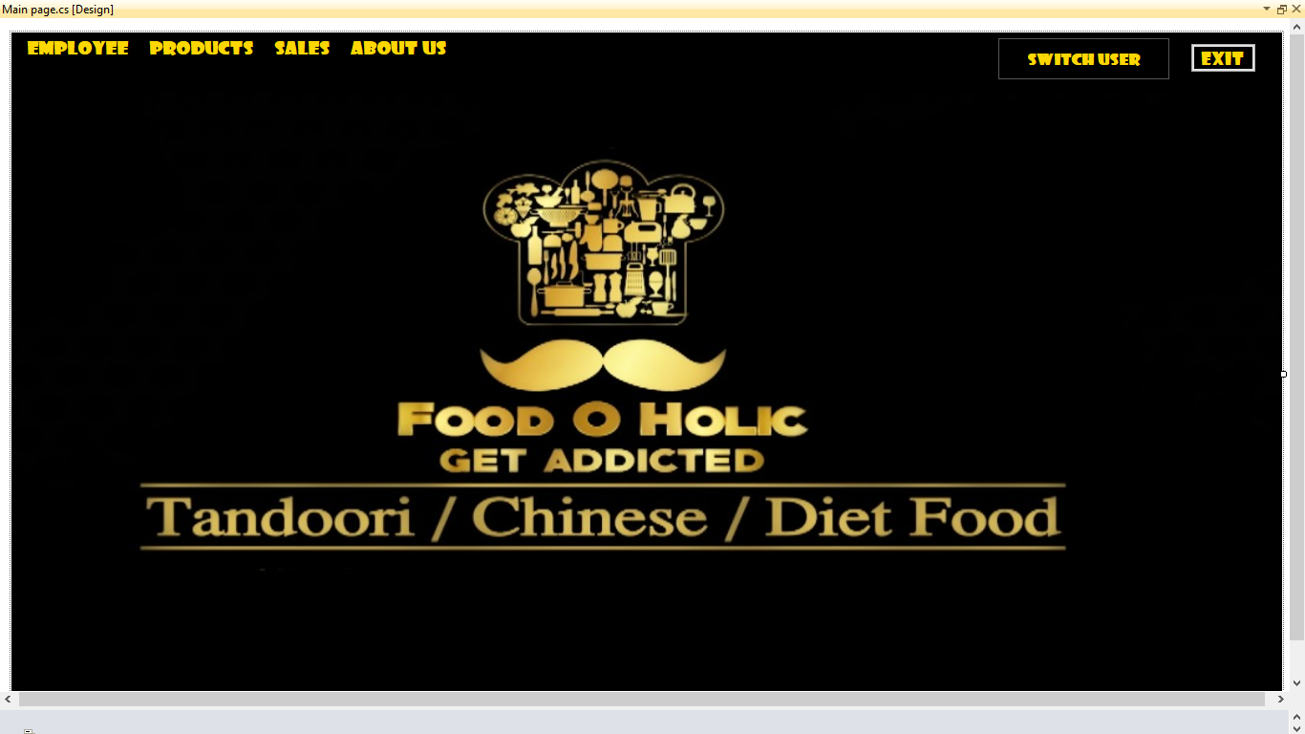

**FIG 7.2 Main page of Restaurant Management System**

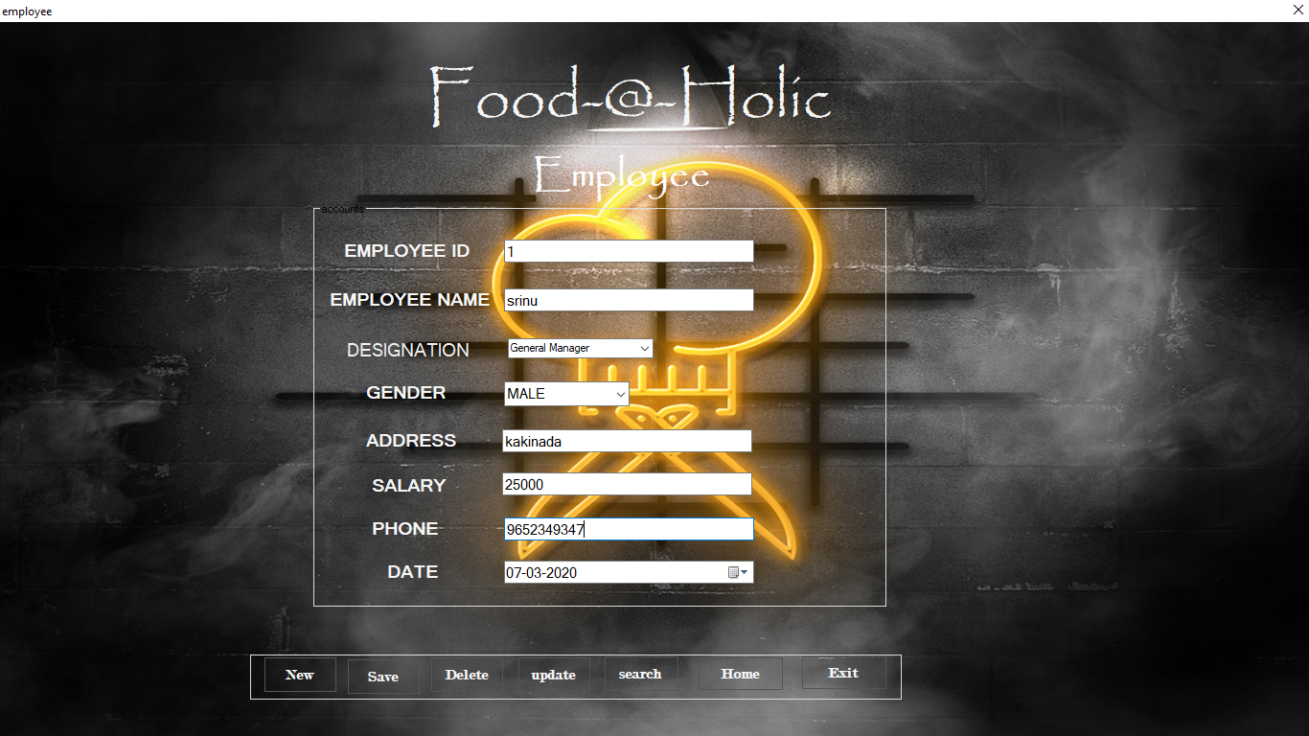

**FIG 7.3 Employee Data entry page of Restaurant Management System**

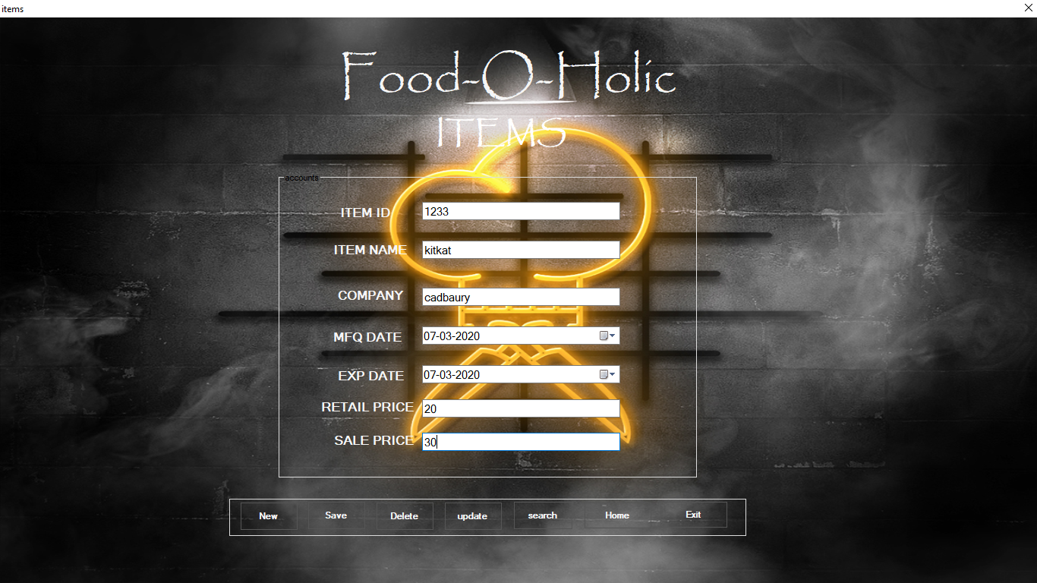

**FIG 7.4 Items Data entry page of Restaurant Database Management System**

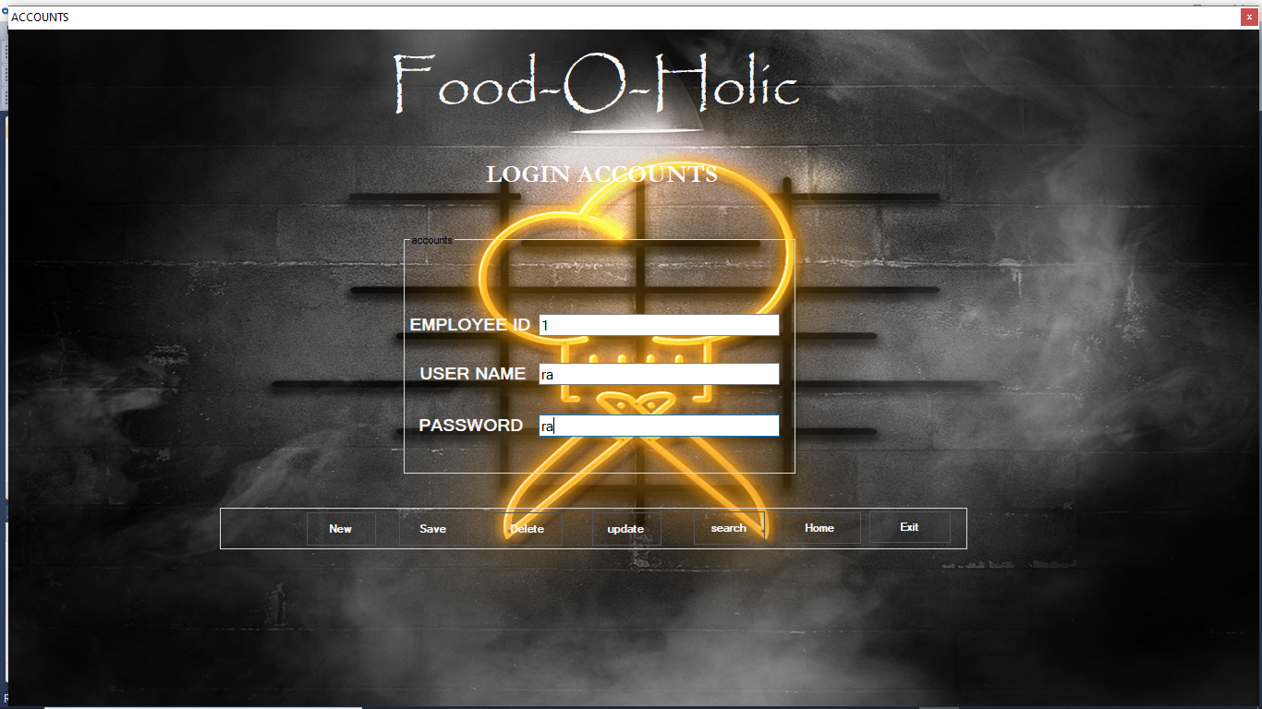

**FIG 7.5 Login details of employee of Restaurant Database Management System**

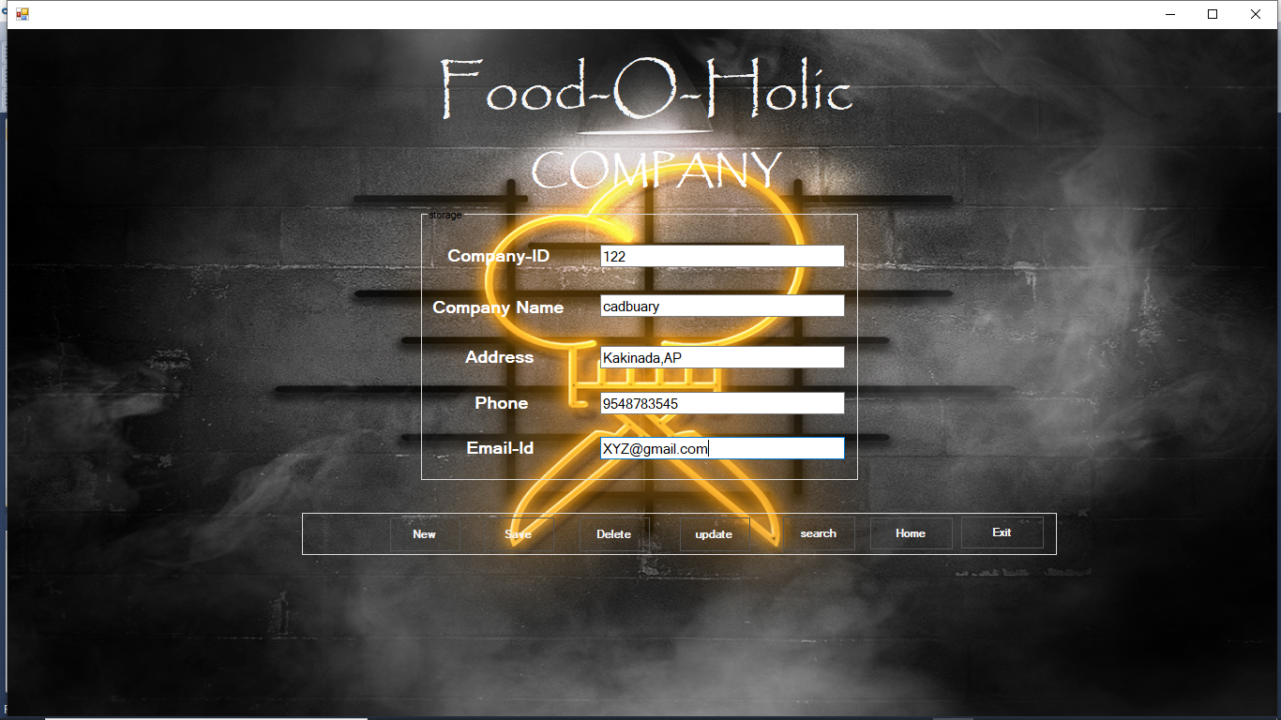

**FIG 7.6 Company data entry page of Restaurant Database Management System.**

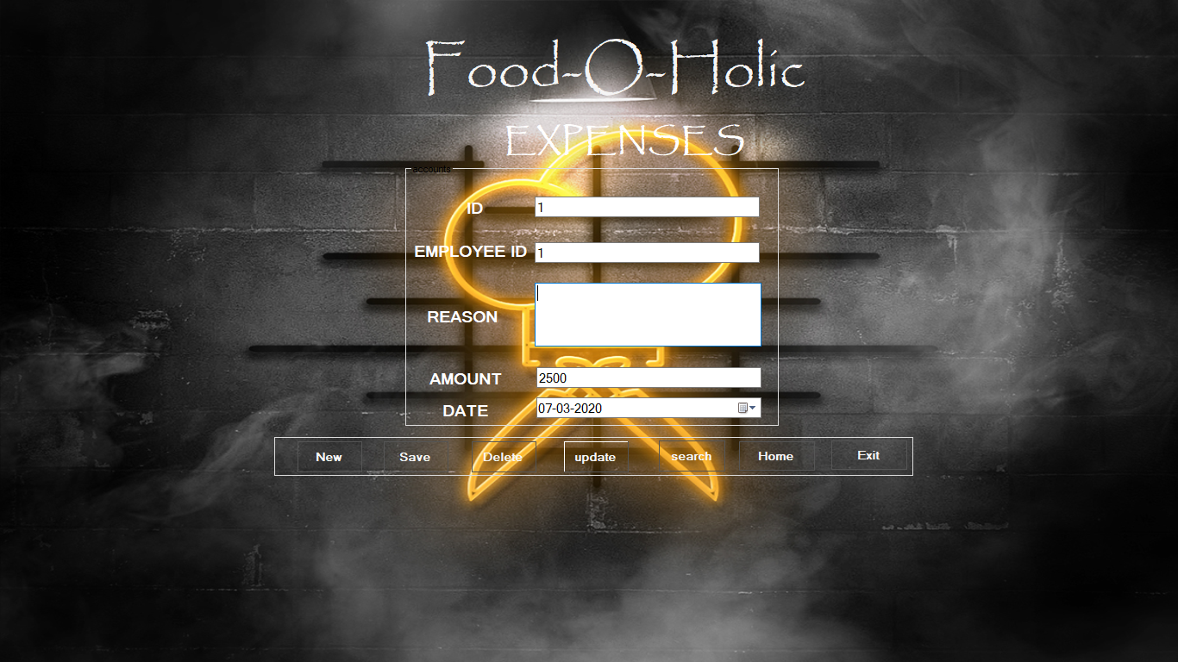

**FIG 7.7 Expenses Management data entry page of Restaurant Database Management System.**

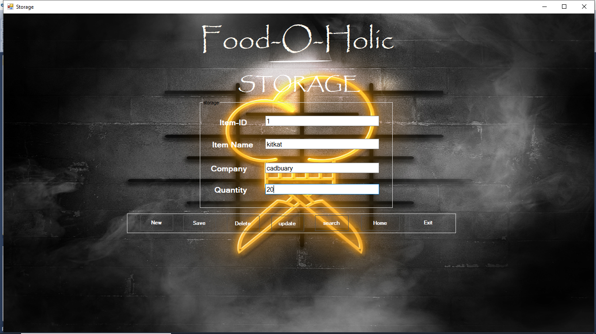

**FIG 7.8 Storage details of Restaurant Database Management System.**

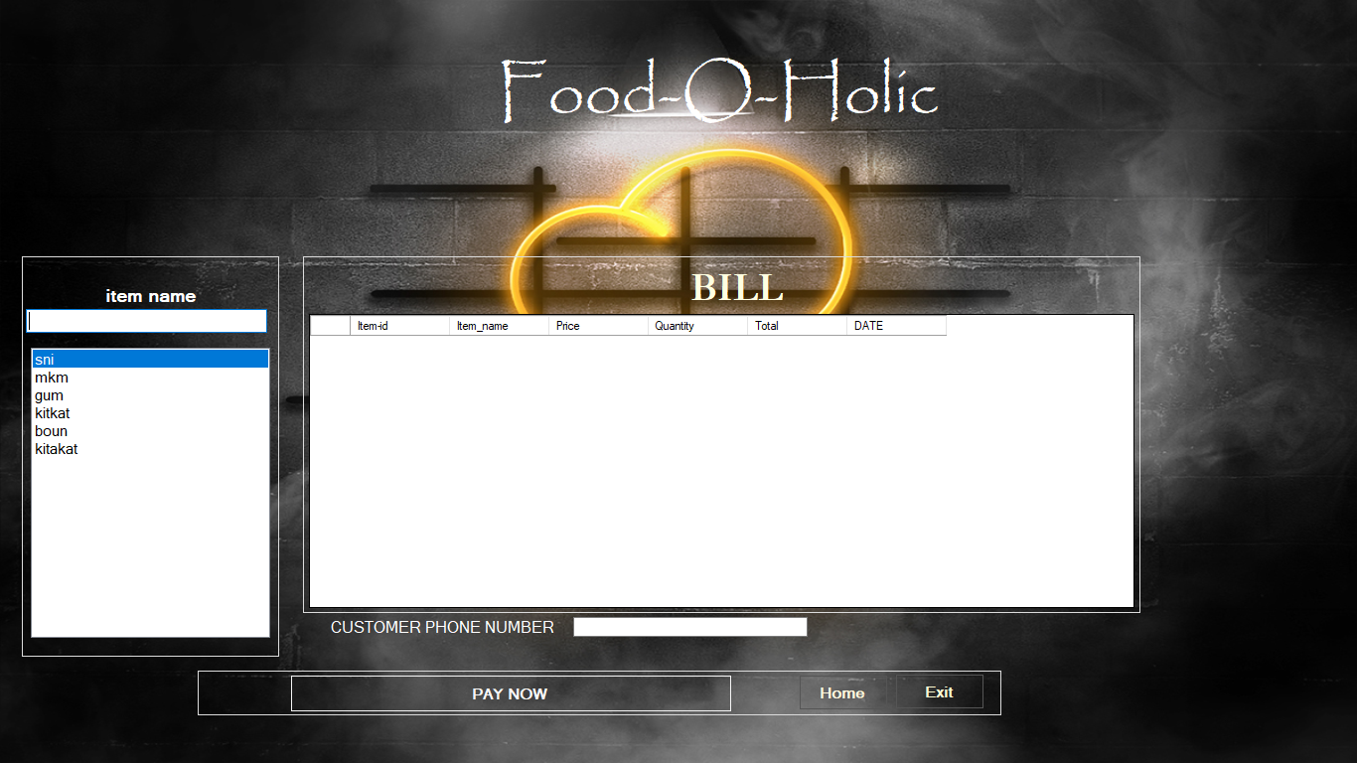

**FIG 7.9 Billing management of Restaurant Database Management System.**

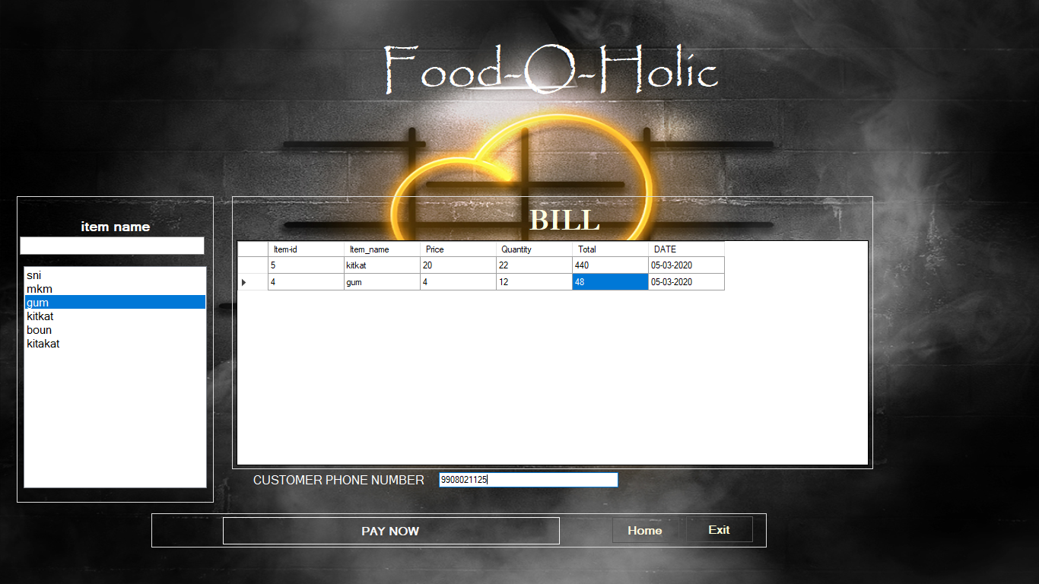

**FIG 7.10 Billing management of Restaurant Database Management System.**

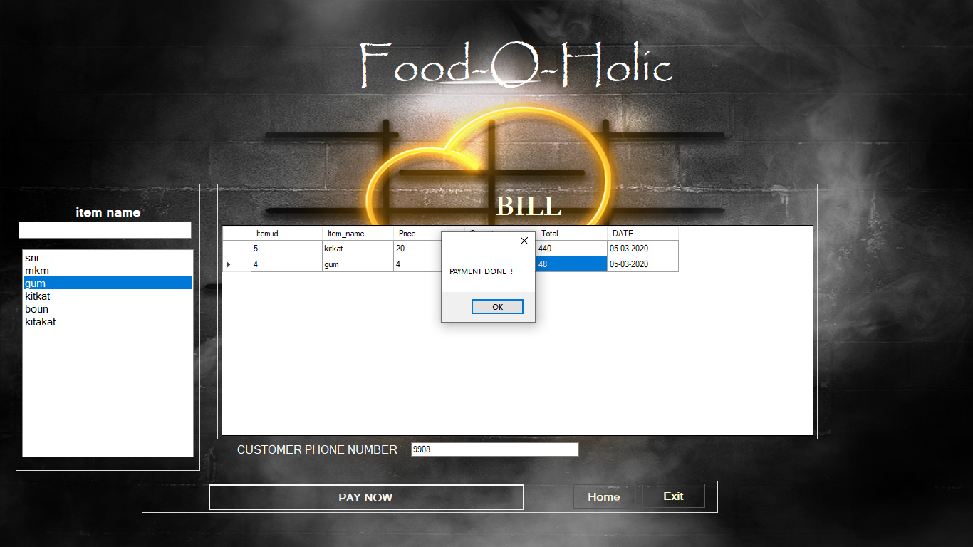

**FIG 7.11 Billing management of Restaurant Database Management System.**

**8.CONCLUSION**

The main aim of developing Reservation System is to provide all information that is required by the users. User friendliness is a quality that the user must get the details without complicated searching procedures. Other requirements of software are data security, extensibility and maintainability. All these features are included in this web application.

The project greatly helped in understanding the various phases in website development and explore to a new developer platform like HTML, CSS, PHP and MySQL.

**9.BIBLIOGRAPHY**

The following books and manuals provided a lot of help to us in making this project a reality.

**Books:**

* Visual Studio by John Paul Mueller.
* Microsoft Access byVirginia Anderson.
* Introduction to C# by Syed Shannu.
* UML Diagrams by Shannumuga Priya

**Website:**

* <http://www.w3>schools.com/ms-access
* http://www.w3schools.com/visual_studio